 PO Box 6004, Rutland, VT 05702
802 747 7900  FAX 802 747 7989
www.vermontwoodlands.org
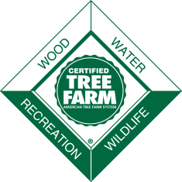
11th ANNUAL WALK IN THE WOODS
TREE FARM TOUR
SATURDAY, August 28, 2021 at 11:00 AM
Pfälzerwald Tree Farm, 1619 Berry Hill Road, Sheffield, VT
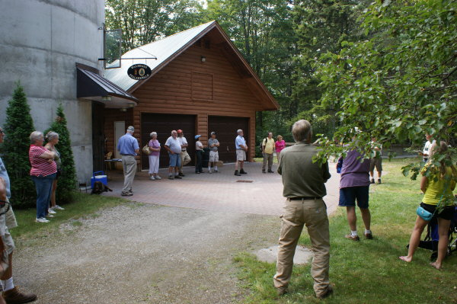
Join Al Robertson, woodland owner and member of the Vermont Tree Farm Committee, on his property as we take a leisurely walk in his forest and

- Enjoy the trails…
- Check out last year’s logging job
- Learn about upcoming resilience plantings and wildlife thinning’s
- Learn about the cider and the orchard
- Talk about how we can help you with your ideas in your woods
- Cider tasting at the end

Our assumption is that most will be vaccinated by this date; for those not vaccinated we will have masks and sanitizer available, and the tour will maintain social distancing. Light refreshments will be served after the walk. This is a field event (rain or shine) so dress accordingly. Mild to moderate hiking on rough trails is required. There is no charge for this workshop (Donations to the VWA/ Vermont Tree Farm Committee welcomed!), and no registration is required.

DIRECTIONS to Pfälzerwald Tree Farm:
Pfälzerwald is located in the town of Sheffield, in the Northeast Kingdom of Vermont adjacent to I-91 between Lyndonville, north of St. Johnsbury, and Barton. Whether traveling north or south on I-91, get off on Exit 24, the Wheelock/ Sheffield exit. The exit puts you on Vermont Route 122. Make a right turn on to Route 122.
Travel Route 122 north approximately 6 miles through Wheelock to Sheffield. (For those coming from the west, travel to the south end of VT Rte 16, on VT Rte 15 east of Hardwick, and go north on VT Rte 16, turning on to the north end of VT Rte 122. Travel VT Rte 122 south to Sheffield). As you enter Sheffield, there is an intersection, with the Post Office on the south side. The road on the north side is Berry Hill Road. Turn and proceed up Berry Hill Road. Follow Berry Hill Road about 1.6 miles, past the intersection with Blake Pond Road/ Maple Row. At about 1.6 miles, on the left, is the gated entrance to Pfälzerwald, 1619 Berry Hill Road. There is a large PFÄLZERWALD TREE FARM sign to the side of the entrance. Proceed, elevation- wise, always up about ¼ of a mile to the house and barn.

Workshop sponsored by the Vermont Woodlands Association,

in partnership with the NorthWoods Stewardship Center

